The dataset **opl_female.csv** contains data on females who have completed in different powerlifting competitions since 1964. The motivation for this data analysis is to explore the relationships between the bench, squat, and deadlift events (in kilograms) in order to gain insights into the performance patterns of athletes. By analyzing relationships, we can understand the interplay between different segments of the competition and potentially identify areas of improvement for athletes. For this activity, we will focus on female competitors who are 25 years old.

1. Watch the Introductory Video
2. Graph and describe the distribution for each event of Open Power Lifting
   1. Bench
   2. Squat See Page 3
   3. Deadlift
3. Graph the following relationships between the legs of the race.
   1. Bench vs. Squat
   2. Bench vs. Deadlift See Page 4
   3. Squat vs. Deadlift

|  |  |  |  |
| --- | --- | --- | --- |
| **Relationship** | **Correlation Appropriate?** | | **Guess for correlation** |
| Bench vs. Squat | Yes | No | r = _________________ |
| Bench vs. Deadlift | Yes | No | r = _________________ |
| Squat vs. Deadlift | Yes | No | r = _________________ |

1. From Question 3, is a correlation an appropriate calculation for these data? If so, guess the correlation between the different events.

|  |  |
| --- | --- |
| **Relationship** | **Correlation**  0.821 |
| Bench vs. Squat | r = _________________  0.782 |
| Bench vs. Deadlift | r = _________________  0.863 |
| Squat vs. Deadlift | r = _________________ |

1. Now, using technology, calculate the correlations and compare them to your guesses

1. Which relationship has the largest correlation? What is a possible reason why we may see this?

r = 0863. A possible explanation for this would be that both squat and deadlift use length strength which isn’t seen when someone benches. They have similar motions.

1. Which relationship has the smallest correlation? What is a possible reason why we may see this?

r = 0.782. A possible explanation for this would be that bench and deadlift have different limitations. Leg strength isn’t a factor when benching weights. Bench requires much more arm strength.

1. This data is only looking at females. How might these relationships be different for males that competed?

Answers may vary

Sample Response: The summary statistics for the histograms which be larger values overall because men in these competitions tend to be able to lift more weight.

1. What do these correlations suggest for athletes about which events they want to concentrate on?

Answers may vary

Sample Response: Focus on bench and one of either squat or deadlift.

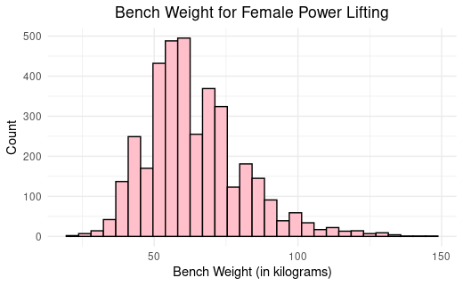

Min: 20

1st Quartile: 52.50

Median: 62.50

Mean: 64.25

3rd Quartile: 72.50

Max: 145

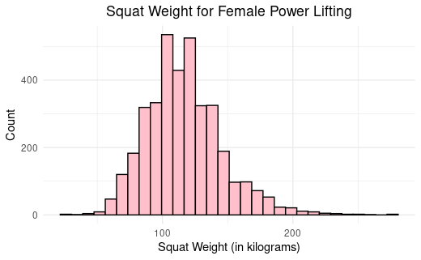

Min: 25

1st Quartile: 97.50

Median: 115

Mean: 116.80

3rd Quartile: 132.50

Max: 275.50

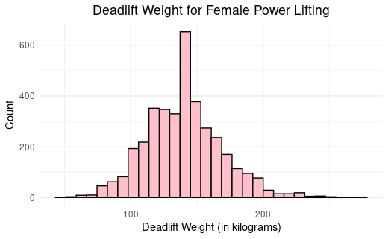

Min: 45

1st Quartile: 120

Median: 140

Mean: 140.20

3rd Quartile: 157.50

Max: 272.5

